SQL Server Deadlock and Deadlock Victim in SQL Server
https://dotnettutorials.net/lesson/sql-server-deadlock-examples/
https://dotnettutorials.net/lesson/sql-server-deadlock-victim-selection/
In this article, I am going to discuss SQL Server Deadlock with an example. Before going to understand what is Deadlock in SQL Server, let’s first discuss when a deadlock occurs in SQL Server.

When a deadlock occurs in SQL Server?

A deadlock occurs in a database when two or more processes have already a resource locked, and then each process wants to acquire a lock on the resource that the other process has already locked. In such cases, neither of the processes can move forward, as each process is waiting for the other process to release the lock.

If you are confused, then just have a look at the following diagram which explains the above points i.e. when a deadlock occurs in a database.

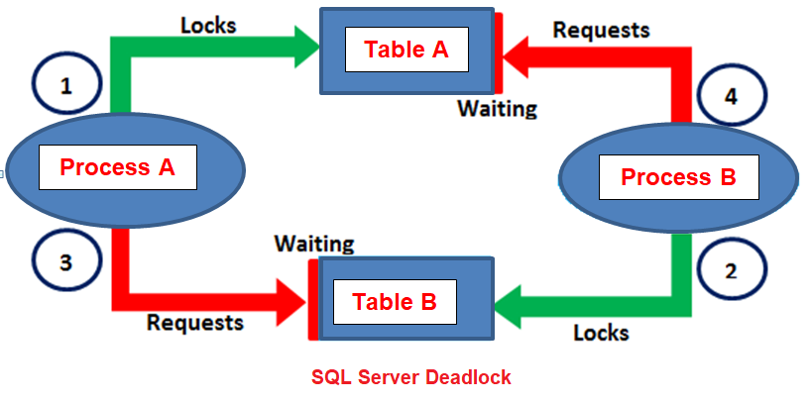
As shown in the above diagram, we have two processes (process means transactions) such as Process A and Process B. We have two tables such as Table A and Table B in the database. The Process A started and it acquires a lock on table A and in the meantime the Process B started and it acquired a lock on Table B. Now to complete its execution, the process A needs the resource Table B which is already locked by the Process B. In the same the Process B needs the resource Table A which is already locked by the Process A. In such cases neither of the transactions (processes) can move forward resulting a deadlock.
When deadlocks occur in SQL Server, then the SQL Server chooses one of the processes (transactions) as the deadlock victim and then rollback that process. As a result, other processes can move forward. The process that is chosen as the deadlock victim will give the following error.
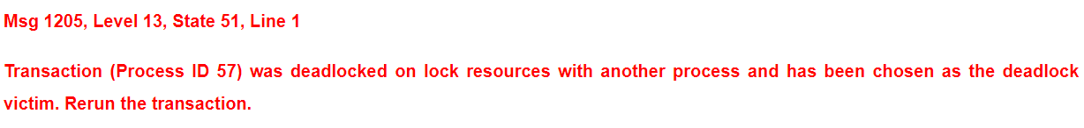

Let us understand Deadlock in SQL Server with an example.
We are going to use the following two tables in this demo.
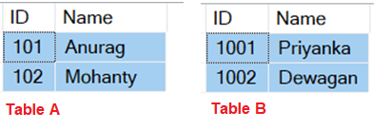
Please use the below SQL Script to create and populate the tables with the test data.

-- Create table TableA
CREATE TABLE TableA
(
ID INT,
Name NVARCHAR(50)
)
Go

-- Insert some test data
INSERT INTO TableA values (101, 'Anurag')
INSERT INTO TableA values (102, 'Mohanty')
Go

-- Create table TableB
CREATE TABLE TableB
(
ID INT,
Name NVARCHAR(50)
)
Go

-- Insert some test data
INSERT INTO TableB values (1001, 'Priyanka')
INSERT INTO TableB values (1002, 'Dewagan')
Go
The following 2 transactions will result in a deadlock situation.
Open 2 instances of SQL Server Management Studio. From the first instance execute Transaction 1 code and from the second instance execute Transaction 2 code.

Transaction 1 Code:

-- Transaction 1
-- Step1 Start
BEGIN TRANSACTION
UPDATE TableA Set Name = 'Anurag From Transaction1' WHERE Id = 101
-- Step1 End

-- From Transaction 2 Window execute the step2 section

-- Step3 Start
UPDATE Tableb Set Name = 'Priyanka From Transaction1' WHERE Id = 1001
-- Step3 End

-- From Transaction 2 Window execute the step4 section
COMMIT TRANSACTION

Transaction 2 Code:
-- Transaction 2
-- Step2 Start
BEGIN TRANSACTION
UPDATE TableB Set Name = 'Priyanka From Transaction2' WHERE Id = 1001
-- Step2 End

-- From Transaction 1 window execute the Step3 section
UPDATE TableA Set Name = 'Anurag From Transaction2' WHERE Id = 101
Commit Transaction

You will notice that after a few seconds one of the transactions completed successfully while the other transaction is chosen as the deadlock victim by giving the following error.

https://dotnettutorials.net/lesson/sql-server-deadlock-victim-selection/

Deadlock Victim in SQL Server
In this article, I am going to discuss how to choose Deadlock Victim in SQL Server with an example. Please read our previous article before proceeding to this article where we discussed when a deadlock occurs in SQL Server with an example. As part of this article, we are going to discuss the following pointers in details
- How deadlocks are detected by SQL Server?
- What happens when a deadlock is detected?
- What is DEADLOCK_PRIORITY?
- What are the criteria that SQL Server uses to choose a transaction as a deadlock victim when there is a deadlock occurred?

How deadlocks are detected by SQL Server?
The Lock Monitor thread of SQL Server by default runs in every 5 seconds to detect if there are any deadlocks occurred in the database. If the Lock Monitor thread finds any deadlocks in the database, then the deadlock detection interval will be a drop from 5 seconds to as low as 100 milliseconds depending on the frequency of the deadlocks. If the Lock Monitor thread stops finding deadlocks, then the Database Engine increases the intervals to 5 seconds.

What happens when a deadlock is detected?
When a deadlock is detected, then the Database Engine ends the deadlock by choosing one of the threads (process or transaction) as the deadlock victim. The transaction which is chosen as the deadlock victim transaction is then rolled back and returns a 1205 error to the application. Rolling back the deadlock victim transaction will release all the locks that are held by the transaction which allows the other transactions to become unblocked and move forward.

What is DEADLOCK_PRIORITY?
As we already discussed when a deadlock occurs, then by default, SQL Server chooses one of the transactions as the deadlock victim and it will choose that transaction which is least expensive to roll back. However, as a user, we can specify the priority of the transactions in a deadlock situation using the SET DEADLOCK_PRIORITY statement. Once you set the deadlock priority, then the transaction with lowest deadlock priority is chosen as the deadlock victim.

Example:
SET DEADLOCK_PRIORITY NORMAL
DEADLOCK_PRIORITY:
- The default priority is Normal
- It can be set to LOW, NORMAL, or HIGH
- It can also be set to an integer value in the range of -10 to 10. (LOW: -5, NORMAL: 0, and HIGH: 5

What are the deadlock victim selection criteria?
The SQL Server uses the following criteria to select the deadlock victim transaction
- If the DEADLOCK_PRIORITY is different, then the transaction with the lowest priority will be selected as the deadlock victim.
- If both the transaction having the same priority, then the transaction that is least expensive to rollback is selected as the deadlock victim transaction.
- If both the transactions having the same deadlock priority as well as same cost, then SQL Server choose one of the transaction as victim randomly.

Let us understand this with an example.
We are going to use the following two tables
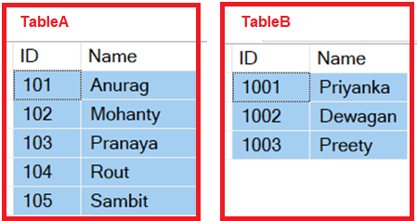
Please use the below SQL Scripts to create and populate the required tables with test data.
-- Create table TableA
CREATE TABLE TableA
(
ID INT,
Name NVARCHAR(50)
)
Go

-- Insert some test data
INSERT INTO TableA values (101, 'Anurag')
INSERT INTO TableA values (102, 'Mohanty')
INSERT INTO TableA values (103, 'Pranaya')
INSERT INTO TableA values (104, 'Rout')
INSERT INTO TableA values (105, 'Sambit')
Go

-- Create table TableB
CREATE TABLE TableB
(
ID INT,
Name NVARCHAR(50)
)
Go

-- Insert some test data
INSERT INTO TableB values (1001, 'Priyanka')
INSERT INTO TableB values (1002, 'Dewagan')
INSERT INTO TableB values (1003, 'Preety')
Go

First, open 2 instances of SQL Server Management Studio.
From the first instance execute the Transaction 1 code and from the second instance execute the Transaction 2 code and here we have not explicitly set the DEADLOCK_PRIORITY, so both the transactions have the default DEADLOCK_PRIORITY which is NORMAL.

So in our example, the SQL Server is going to choose Transaction 2 as the deadlock victim transaction as it is the least expensive to rollback.

Transaction1 Code:

-- Transaction 1
-- Step1 start
BEGIN TRANSACTION
UPDATE TableA Set Name = Name + ' From Transaction 1'
WHERE Id IN (101, 102, 103, 104, 105)
-- Step2 end

-- From Transaction 2 execute the step 2 Section

-- Step3 Start
UPDATE TableB Set Name = Name + ' From Transaction 1'
WHERE Id IN (1001, 1002)
-- Step3 End

-- From Transaction 2 execute the Step4 Section

Commit Transaction

Transaction2 Code:

-- Transaction 2
-- Step2 Start
BEGIN TRANSACTION
UPDATE TableB Set Name = Name + ' From Transaction 2'
WHERE Id IN (1001, 1002)
-- Step2 end

-- From Transaction 1 execute the Step3 Section

-- Step4 Start
UPDATE TableA Set Name = Name + ' From Transaction 2'
WHERE Id IN (101, 102, 103, 104, 105)
-- Step4 End

-- After a few seconds you will see that this transaction will be chosen as the deadlock
-- victim as it is least expensive to rollback than the transaction 1
Commit Transaction

Here you will notice that the Transaction 2 will be chosen as the deadlock victim and rollback by giving the following error.

Let’s back the data to its original state by using the following query.

Truncate table TableB
Truncate table TableA

INSERT INTO TableA values (101, 'Anurag')
INSERT INTO TableA values (102, 'Mohanty')
INSERT INTO TableA values (103, 'Pranaya')
INSERT INTO TableA values (104, 'Rout')
INSERT INTO TableA values (105, 'Sambit')

INSERT INTO TableB values (1001, 'Priyanka')
INSERT INTO TableB values (1002, 'Dewagan')
INSERT INTO TableB values (1003, 'Preety')

Let’s rewrite the same example to use the SET DEADLOCK_PRIORITY of Transaction 2 to HIGH, so that the Transaction 1 will be chosen as the deadlock victim. This is because the Transaction 1 is having the default DEADLOCK_PRIORITY which is Normal and it is lower than the DEADLOCK_PRIORITY of Transaction 2.

-- Transaction 1
-- Step1 start
BEGIN TRANSACTION
UPDATE TableA Set Name = Name + ' From Transaction 1'
WHERE Id IN (101, 102, 103, 104, 105)
-- Step2 end

-- From Transaction 2 execute the step 2 Section

-- Step3 Start
UPDATE TableB Set Name = Name + ' From Transaction 1'
WHERE Id IN (1001, 1002)
-- Step3 End

-- From Transaction 2 execute the Step4 Section

Commit Transaction

-- Transaction 2
-- Step2 Start
SET DEADLOCK_PRIORITY HIGH
GO
BEGIN TRANSACTION
UPDATE TableB Set Name = Name + ' From Transaction 2'
WHERE Id IN (1001, 1002)
-- Step2 end

-- From Transaction 1 execute the Step3 Section

-- Step4 Start
UPDATE TableA Set Name = Name + ' From Transaction 2'
WHERE Id IN (101, 102, 103, 104, 105)
-- Step4 End

Commit Transaction

Here you will notice that the Transaction 1 will be chosen as the deadlock victim

SQL Server Deadlock Analysis and Prevention

https://dotnettutorials.net/lesson/sql-server-deadlock-analysis-and-prevention/
In this article, I am going to discuss SQL Server Deadlock Analysis and Prevention i.e. how to read and analyze the Deadlock Information captured in the SQL Server error log, so that we can understand what’s exactly causing the deadlocks and then we can take the necessary actions to prevent or minimize the occurrence of deadlocks. Please read the following article before proceeding to this article as it is the continuation part of that article where we discussed how to log the Deadlock information in SQL Server Error Log.

https://dotnettutorials.net/lesson/deadlock-logging-sql-server-error-log/
So please execute the following command to see the Error Log
EXECUTE sp_readerrorlog
Once you execute the above command then search for the deadlock-list as shown below in the result set.
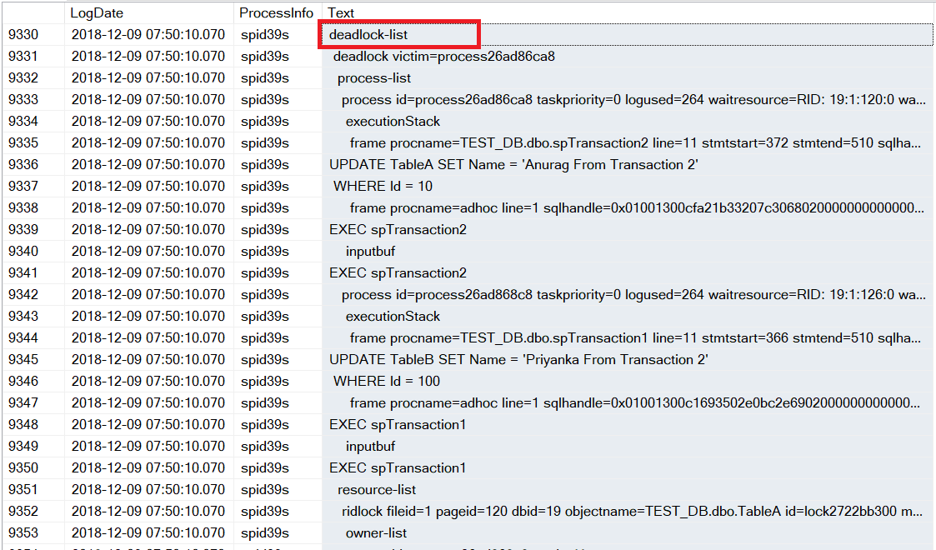

Let’s understand the above code in detail.
The deadlock information that is stored in the SQL Server Error Log has three sections
- Deadlock Victim
- Process List
- Resource List

Deadlock Victim:
It contains the Process ID that was selected as the deadlock victim process and then killed by the SQL Server. The following section of the Error Log shows this.
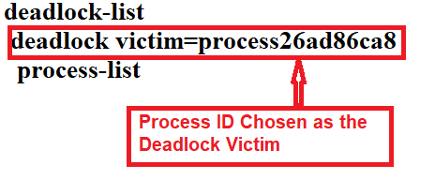

Process List:
The Process List section contains the list of processes that were participated in the deadlock. The following diagram shows that there are two processes are participated in the deadlock and the first process was selected as the Deadlock victim.
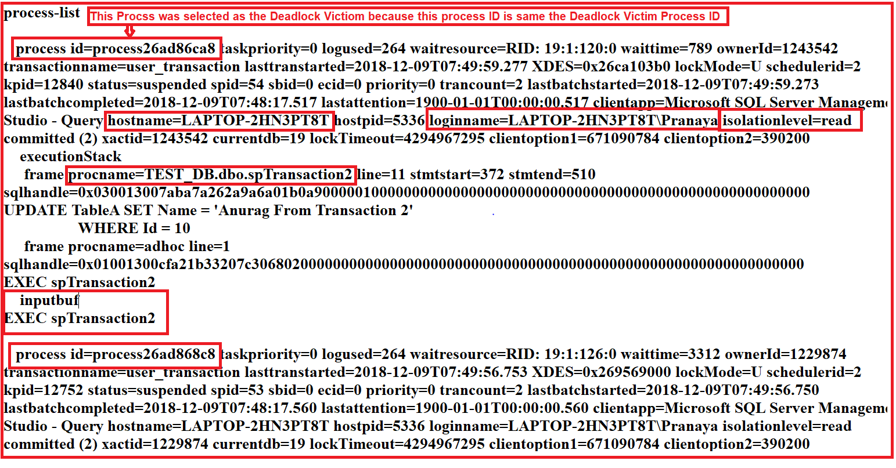
As you can see from the above diagram, the Process List section contains a lot of useful information to understand and handle the deadlock is as follows.
- Process ID: It is the unique id of the process.
- Loginname: The Login which is associated with the process.
- Isolationlevel: It specifies which Isolation Level is used with the transaction. As we have not specified any Isolation Level explicitly so it takes the default Isolation Level which is nothing but Read Committed.
- Hostname: It specifies the Host Name
- procname: It provides the fully qualified name of the stored procedure
- Inputbuf: The code the process that is executing when the deadlock occurred i.e. EXEC spTransaction2

Resource List:
The Resource List section provides the information which is particularly useful when we try to understand what caused the deadlock. The following diagram shows the Resource List section of the Deadlock.
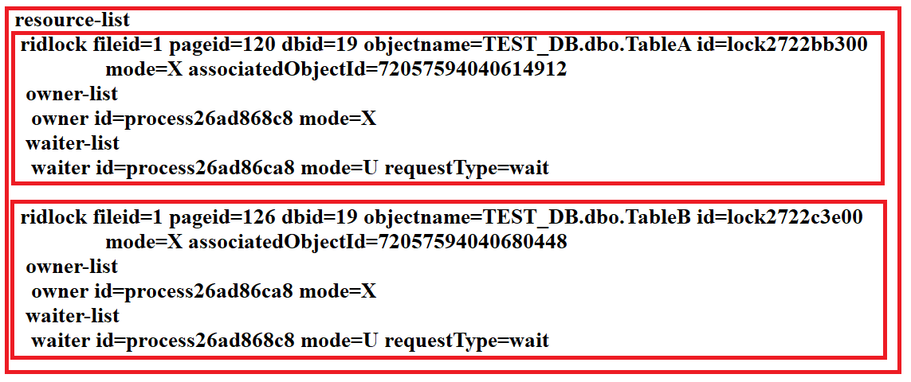

The Resource List contains the following items
objectname: The Fully qualified name of the resource which is involved in the deadlock

owner-list: It contains (owner id) the id of the owning process and the lock mode it has acquired on the resource. The lock mode determines how the resource can be accessed by concurrent transactions. S for Shared lock, U for Update lock, X for Exclusive lock, etc.

waiter-list: It contains (waiter id) the id of the process that wants to acquire a lock on the resource and the lock mode it is requesting
To prevent the deadlock that we have in our example, we need to ensure that the database objects such as Table A & Table B are accessed in the same order every time.
Let’s see how to do this.

Modify both the Stored Procedures as shown below.

ALTER PROCEDURE spTransaction1
AS
BEGIN
BEGIN TRANSACTION
UPDATE TableA SET Name = 'Anurag From Transaction 1'
WHERE Id = 101

WAITFOR DELAY '00:00:10'

UPDATE TableB SET Name = 'Priyanka From Transaction 2'
WHERE Id = 1001
COMMIT TRANSACTION
END

ALTER PROCEDURE spTransaction2
AS
BEGIN
BEGIN TRANSACTION
UPDATE TableA SET Name = 'Anurag From Transaction 2'
WHERE Id = 101

WAITFOR DELAY '00:00:10'
UPDATE TableB SET Name = 'Priyanka From Transaction 2'
WHERE Id = 1001

COMMIT TRANSACTION
END

Now open two instances of SQL Server Management Studio and from instance 1 execute the spTransaction1 stored procedure and from the second instance execute the spTransaction2 and you will see there is no deadlock and both the transactions are executed successfully.

